**Computer Experiment Analysis Report**

1. What is the general question you seek to answer?

On my laptop, how can I get the best synthetic benchmark scores for my CPU depending on the voltage allowed to my CPU (this is measured in an offset based on the standard voltage to the CPU) and clock speeds for the CPU (3.3,3.4 ect).

After building my own computer, I want to optimize the performance of my CPU so that I am not only getting the advertised performance of AMD 7700x but also that I’m getting the best performance while keeping the temperature and power consumption of my 7700x within reason

1. What is your motivation for studying this question?  
   My motivation for studying this is I love playing with computers and trying to overclock (OC) and maximize performance on my laptop.

I have always loved playing with computers and trying to overclock the CPU and GPU in order to get the best possible performance out of them. Now that I’ve finally built my own computer, I’m still interested in squeezing out as much performance out of my CPU as possible but I want to achieve that performance with reasonable temperature and power consumption as to not damage my CPU in the long run.

3 Choices: responses, conditions, material

1. [2] Identify your response.

I’ll be using one run (test) of the synthetic benchmarks ‘Cinebench R23’ to objectively measure CPU performance. (ex. a score of 6363)

In order to measure the performance of my CPU at various settings my dependent variable with a custom run of the synthetic benchmark “Cinebench R23” with the minimum time duration of the test set to 1 minute. After the test “Cinebench R23” will output a score telling me how well my CPU perfomaned (like 6363).

* + [1] What 2 factors did you study and what are the levels of each factor?   
     The factors of interest that I am going to be investigating in this study is going to **voltage to the CPU** (measured in an offset as I will actually be ‘down-volting’ the CPU by giving it less power (ex. 0 being normal settings, -80.1 and -160.2) so it wont over heat which should give extra performance to the CPU) and the **clock speed** of the CPU (3.4, 3.5 GHz ect)

For my independent variables that will hopefully impact CPU performance, I’ll be looking at two factor variables: voltage and clock speed. Starting with the voltage supplied to the CPU, the four factors I will be testing are 1.1, 1.175 (default), 1.225, and 1.275 volts. CPU clock speed measures the number of cycles a CPU can execute per second and the four factors I’ll be examine here are 4, 4.5, 5, and 5.4 GHz.

* + [1] Identify each of these factors as an **observational factor** or an **experimental factor**. For an observational factor, the levels are “built into” the units, like the conditions in an observational study; for an experimental factor, the levels are assigned to the units, like the conditions in an experiment. **It is required that at least one of the factors be an experimental factor**.

Both factors in my experiment are going to be experimental factors as I am going to be artificially setting the speed of the CPU clock speed and the number for the offset voltage, which will be negative since I’m going to be down-volting my CPU.

1. [2] Identify the experimental units. (This is what you assign the treatments to.)   
     
   In this case, the experimental unit would be one run of the program Cinebench R23
2. [1] What is the specific question you seek to answer?(This comes from applying your choices of the response, conditions, and the material to the more general question you posed at the beginning.)  
   ­­­  
   How is the performance of the CPU, measured through the synthetic benchmark ‘Cinebench R23’, affected by its core clock speed (GHz) and voltage offset when the fan curve is set to default.
3. [1] It is required that you complete an experiment, not an observational study. Explain why your study will be an experiment and not an observational study, as defined on Notes 1.
   * My study will be an experiment and not an observational study because I would be assigning the conditions.

Anticipating sources of variation, bias, and confounding

1. [2] Describe your process of collecting a few preliminary response values. If this was not possible, explain what you did instead. Did this process help you consider any issues in carrying out the experiment you did not consider before?   
     
   While I was testing I wondered whether I should keep the fans on my constant setting (max speed) while changing the voltage and Clock Speed between tests. I decided I should leave the fan speed at the constant (max speed) at all times during testing in order to help get rid of any temperature variations between tests when I am changing the clock speed and CPU voltage.

Prior to my data collection, I ran some preliminary Cinebench R23 tests to see if I needed to address any sources of variation, bias, and confounding. One thing I noted was that after each test run my CPU would get significantly hotter than when it was idle (which means it’s working hard). So I had to be careful not to run my tests too close together otherwise leftover heat from the previous test might influence the performance of my next test. To combat this potential issue I measured what my CPU’s idle temperature was and before moving onto the next test I made sure my CPU reach that same idle temperature.

Another source of variation that might come up is ambient temperature. So as I run successive tests on my CPU, the outputted heat will warm the room I’m in increasing the idle temperature of my CPU and thereby potentially hurting the performance of my CPU. To combat this, I’m going to keep a thermometer in on my desk which is right next to my computer I’m working at to make sure it the temperature doesn’t increase significantly. In addition, I’ll be keeping track of my trial order to ensure that as the testing goes on the CPU doesn’t reach hotter temps than it would have if I ran it earlier in the testing phase.

1. [3] Describe your measurement process (i.e. of obtaining the response values), including what steps you took to minimize measurement error.  
     
   The synthetic program for measuring performance of the CPU, Cinebench R23, will give me a performance score (like 6800) at the end of each test run and as long as I set the clock speed and voltage offset correctly there should no chance of a measurement error.
2. [1] To what degree are the units representative of the question you seek to answer?

While the CPU and the laptop I am using may have similar or exact components to other laptops with the same name and specifications, there is a thing in the computer industry called ‘Silicon lottery’ where the performance of each CPU and therefore computer can differ because the materials that make each CPU will be slightly different. This might allow the same CPU in one computer to achieve higher scores than the same CPU in another computer. So, in theory my testing with my CPU should be representative with all other CPUs of the same spec but unfortunately due to the ‘Silicon lottery’ that’s not really the case.

1. [2] To what degree are the units uniform (to limit variability)? What did you do to make them more uniform?  
    Since I’ll be using my laptop for these runs I’ll keep the clock speeds and the voltage of the CPU the same while making sure fan speeds do not change from run to run as well as having the computer sit on my desk every time I get test results so that my desk surface should heat up at the same pace every time. And I will be measuring the ambient temperature to make sure its roughly the same from run to run.
2. [2] What other nuisance factors are present? (factors other than those of interest that might cause variation/bias in the response) What did you do about them?   
     
   One other Nuisance factor that might be present is the ambient temperature surrounding my computer. Since It’s known that excessive heat is bad for a computer and can cause it to run slower it’s imperative that I keep the ambient temperature around my computer the same for all tests. In addition, since I’ll be testing my laptop on my desk It’s important for my desk to be the same temperature at the start of each test run. So, to make sure these factors don’t influence my results I am going to be keeping a thermostat on my desk to make sure the ambient temp is consistent. I will also be doing several test runs in order to heat up my computer and the desk it’s sitting on to keep the temperature as consistent as possible throughout all the trials otherwise the later results might be disproportionately lower since the computer and desk would have been allowed to heat up.
3. [1] Identify at least one nuisance influence that you recorded as part of your dataset.

One nuisance influence that I am going to record as part of my dataset is going to be trial number to make sure the responses are roughly the same regardless of when test run was conducted.

Random assignment / the Design

1. [1] How many treatments did you have? How many replications (units) per treatment? How many total observations?

|  |  |  |  |
| --- | --- | --- | --- |
| Offset Voltage (Mv) of CPU | CPU Clock Speed (GHz) | |  |
| 3.3 | 3.4 | 3.5 |
| 0 (essentially default voltage) | 0, 3.3 | 0, 3.4 | 0, 3.5 |
| -80.1 | -80.1, 3.3 | -80.1, 3.4 | -80.1, 3.5 |
| -160.2 | -160.2, 3.3 | -160.2, 3.4 | -160.2,13.5 |

Based on this diagram I will have 9 different treatments (3 for CPU and 3 for voltage) doing 2 replications per treatment would leave me with a total of 18 observations

|  |  |  |  |  |
| --- | --- | --- | --- | --- |
| Offset Voltage | CPU Clock Speed (GHz) | | | |
| 4 | 4.5 | 5 | 5.4 |
| 1.1 | 1.1, 4 | 1.1, 4.5 | 1.1, 5 | 1.1, 5.4 |
| 1.175 | 1.175, 4 | 1.175, 4.5 | 1.175, 5 | 1.175, 5.4 |
| 1.225 | 1.225, 4 | 1.225, 4.5 | 1.225, 5 | 1.225, 5.4 |
| 1.275 | 1.275, 4 | 1.225, 4.5 | 1.225, 5 | 1.225, 5.4 |

Based on this diagram I will have 16 different treatments doing 2 replications per treatment which results in a total of 32 observations.

1. [1] What is the design name
   * **two-way completely randomized (CR[2]) design**

1. [2] Show output from PROC PLAN that you used in randomly assigning treatments to units. What was the seed that SAS used (not supplied by you)?  
     
   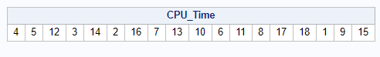

Seed = 164351913

  
seed = 123

1. [2] Explain how you used this PROC PLAN output to randomly assign treatments to units.  
     
   Okay so using this chart I marked off each treatment with 2 numbers. And depending on where those numbers come up in the sequence in the chart above I will be testing that combination. Example, since the first number is 4 I will test the CPU performance by using a voltage at 0 and CPU clock speed at 3.4

|  |  |  |
| --- | --- | --- |
| 0, 3.3 (1-2) | 0, 3.4 (3-4) | 0, 3.5 (5-6) |
| -80.1, 3.3 (7-8) | -80.1, 3.4 (9-10) | -80.1, 3.5 (11-12) |
| -160.2, 3.3 (13-14) | -160.2, 3.4 (15-16) | -160.2,13.5 (17-18) |

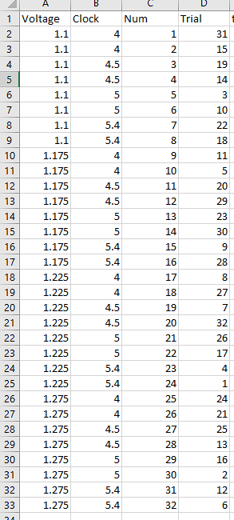

To randomly assign treatments to each unit, I initially gave every a treatment a number going in order from 1 to 32. Then I used R to randomly shuffle those numbers and the new number that was there I inputted into the Trail variable and that’s when that specific treatment would be tested

Data collection

1. [4] Describe your process of data collection, providing enough detail that someone else could repeat your experiment.  
     
    First, in order to make sure the computer and table is saturated with heat **I ran “Cinebench R23” 5 times** on normal fan settings at an uncapped GHz and default voltage before recording any results. After that I’ll be using a piece of software called throttlestop to artificially set my CPU clock speeds at the desired level (as 3.3, 3.4 GHz ect.) as well as to lower the CPU Offset voltage by moving the slider to the left. Then I’ll launch the application called “Cinebench R23” (using it to measure CPU performance) and set the program to run only once, click start next to the ‘CPU (Multi Core)’ button and wait for the benchmark to finish and record the score.

[2] Include at least two photos here that help to describe your experiment, writing about what they show.  
  
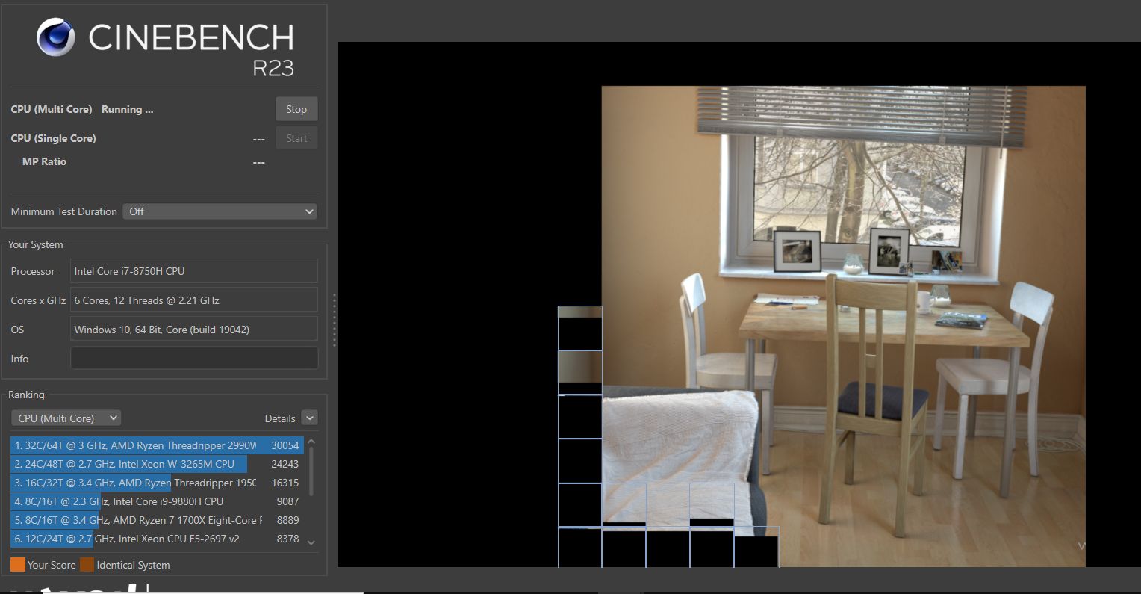 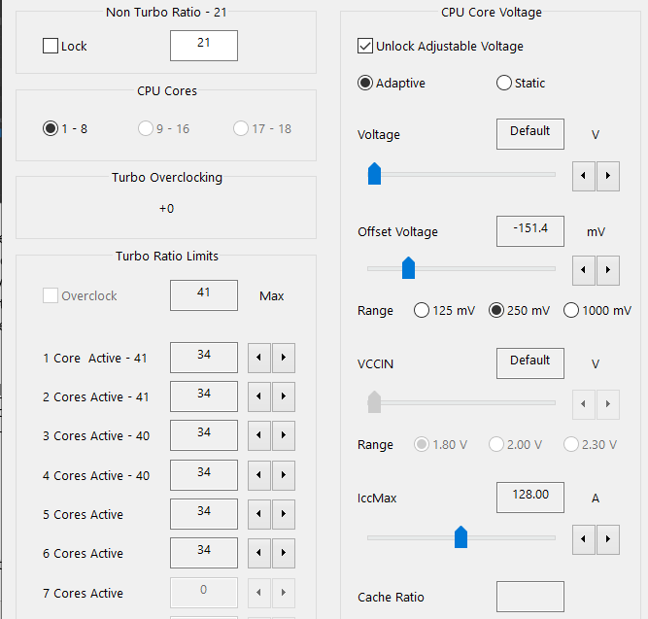  
  
The picture on the left shows the synthetic benchmark ‘Cinebench R23’ that I will be using to measure the performance of my intel CPU and you can see the picture with the table and chairs is the imagine that my CPU is trying to render in and once that picture is complete Cinebench R23 will give my CPU a score. On the bottom left you can see the scores that other CPUs have scored on this same benchmark. The picture on the right is “ThrottleStop” and in the red circle you can see where I can adjust the clock speed for my CPU. In the green circle you can see the voltage offset where I move the slider to the left giving me a negative offset which lowers the amount of power the CPU gets which, in theory, should lower the CPU temperature that’ll also give me better performance scores.

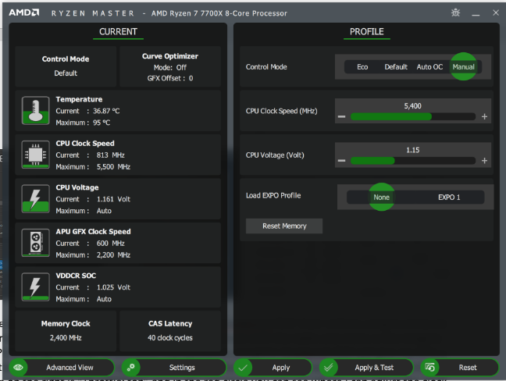

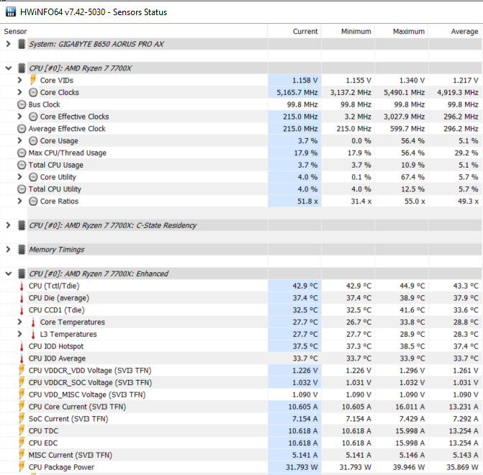

1. [2] What are the degrees of freedom associated with each factor? You are required to have at least 6 degrees of freedom for residual error.

|  |  |  |  |  |
| --- | --- | --- | --- | --- |
| Factors | Outside factors | # Levels | Sum of df for outside factors | df |
| Grand avg | None | 1 | 0 | 1 |
| Clock Speed | Grand Average | 3 | 1 | 2 |
| Voltage | Grand average | 3 | 1 | 2 |
| Interaction | Voltage, Clock Speed, Grand average | 9 | 5 | 4 |
| Residual Error | Grand average, interaction, voltage, clock speed | 18 | 9 | 9 |

|  |  |  |  |  |
| --- | --- | --- | --- | --- |
| Factors | Outside factors | # Levels | Sum of df for outside factors | df |
| Grand avg | None | 1 | 0 | 1 |
| Clock Speed | Grand Average | 4 | 1 | 3 |
| Voltage | Grand average | 4 | 1 | 3 |
| Interaction | Voltage, Clock Speed, Grand average | 16 | 7 | 8 |
| Residual Error | Grand average, interaction, voltage, clock speed | 18 | 15 | 13 |

Data analysis and interpretation

1. [2] Copy and paste the Excel file that shows the dataset used to analyze the data in SAS. This should include variables for each factor, the response, the nuisance influence(s) you recorded, and the blocks (if applicable).  
   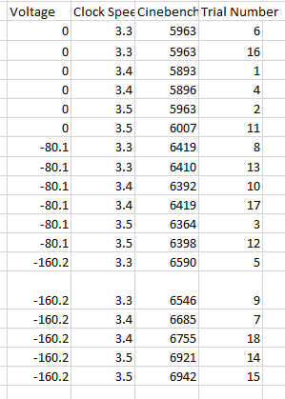

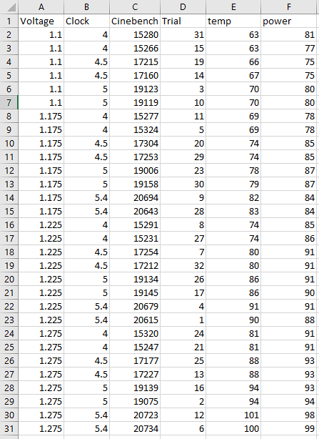

1. [2] Copy and paste a parallel dot plot of the dataset. The x-axis should have locations for each of the treatments and the y-axis should show the response. Use formats and labels so the variables and treatments are described clearly (and are not shown as abbreviations). If blocking is part of your data, this should be a connected parallel dot plot.

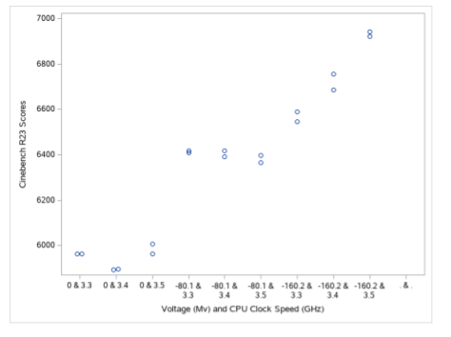

1. [2] Interpret this parallel dot plot in terms of the means and spreads of the responses in each of the treatments.  
    Mean response of Cinebench R23 score tends to increase going left to right as the voltage goes down and once the voltage hits -160.2 Cinebench scores increase again as the clock speed increases. The spread of the responses is fairly similar for voltages of 0 and -80.1 Mv regardless of clockspeed, however, once voltages hit -160.2 there is a lot of spread as the CPU clock speed increases.
2. Check the assumptions. Copy and paste each plot mentioned below and state why it gives evidence the given assumption is satisfied or violated.
   * [1] Constant standard deviation and the residual vs. predicted plot.

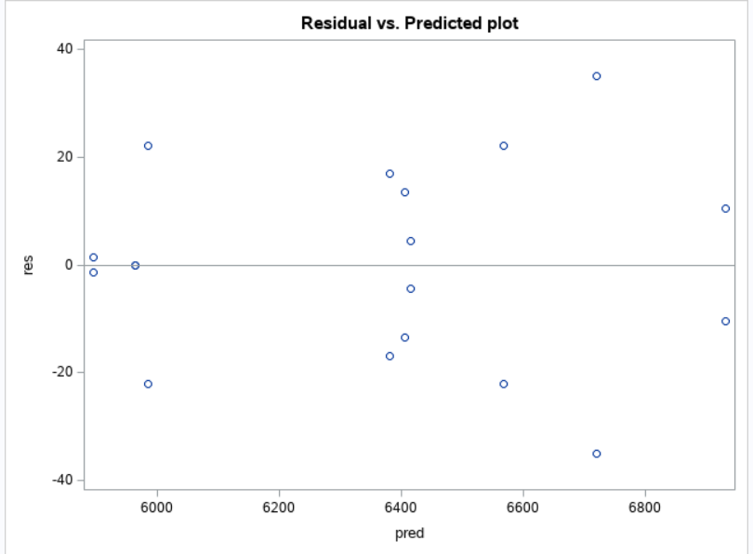

The constant standard deviation assumption is not met because the spread of the residuals is not constant as there is less spread on the outsides of the graph than in middle of the graph.

[1] Normality assumption and normal quantile plot  
 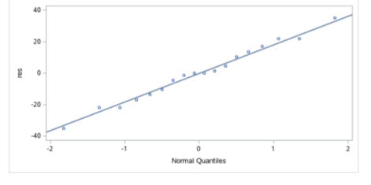  
On the normal quantile plot, the points follow the line extremely well so the normality assumption is met.

* + [1] Independence assumption and plot of residuals vs. your nuisance influence (such as trial number).   
    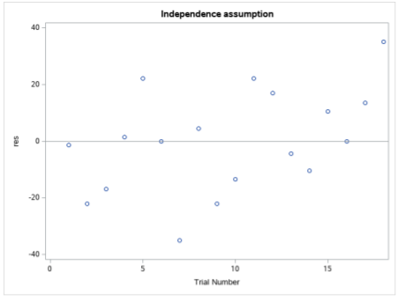

I do not see any patterns based off of this graph, which means that the independence assumption is thoroughly met as trial number had no effect on the outcome of the data.

1. Interaction
   * [1] Copy and paste an interaction plot made by SAS.   
       
     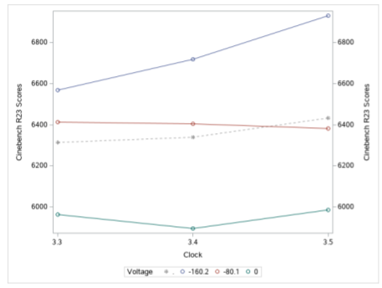

* + [1] Copy and paste a table of the means of the response for each treatment combination.  
    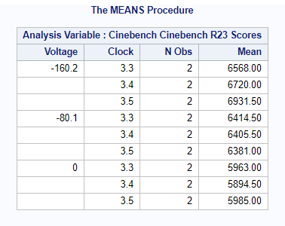  
    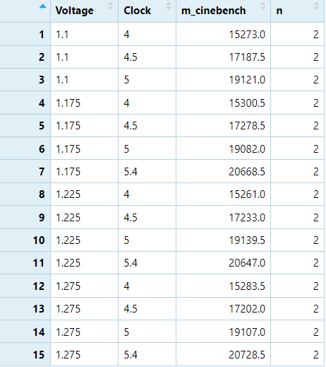

1. [3] Explain whether or not interaction is present in your dataset in terms of **both** the interaction plot and the table of means above.  
    An interaction is present in the interaction plot since no where in the graph are the lines entirely parallel although they get close when the voltage is at 0 and -80.1 going from clock speeds 3.3 to 3.4 GHz. We can more clearly see that an interaction is taking place by looking the table of means I converted into this nice chart below and subtracted horizontally and vertically and compared those differences together to see that they were all different values indicating an interaction.

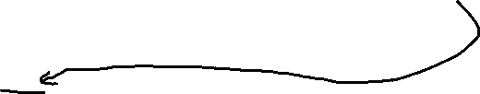

|  |  |  |  |
| --- | --- | --- | --- |
| Offset Voltage (Mv) of CPU | CPU Clock Speed (GHz) | |  |
| 3.3 | 3.4 | 3.5 |
| 0 (essentially default voltage) | 5963.00 | 5894.50 | 5985.00 |
| -80.1 | 6414.50 | 6405.50 | 6381.00 |
| -160.2 | 6568.00 | 6720.00 | 6931.50 |

voltage 0 = -5,916.5 Clock 3.3 = -7,019.5

voltage -80.1 = -6,372 Clock 3.4 = -7,231

voltage -160.2 = -7,083.5 Clock 3.5 = -7,327.5

1. [2] Copy and paste SAS output that gives as much of entries in the ANOVA table as possible.  
   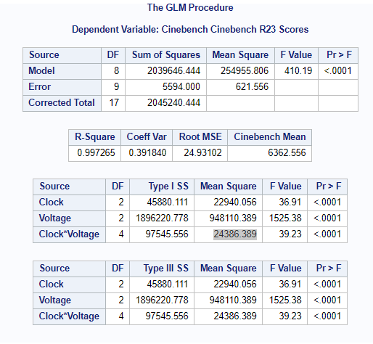

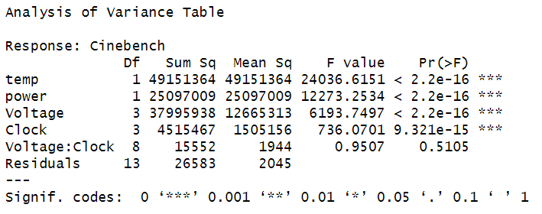

1. [2] Interpret the F-ratios for each factor and for interaction.  
     
   A. The average variation due to GPU Clock Speed is 36.91 times the average variation due to residual error.

B. The average variation due to voltage is 1525.38 times the average variation due to residual error.

C. The average variation due to the interaction of voltage and CPU Clock Speed is 39.23 times the average variation due to residual error.

1. [2] Find the residual standard deviation and interpret it within the context of the experiment.  
     
   Residual standard deviation = 24.93 On average, the distance between the observed and predicted CineBench R23 Score for the CPU is 24.93 points
2. [2] Should you interpret the main effects or simple effects of the factors of interest? (This decision should be based on a hypothesis test at the 0.05 significance level.) Justify your decision.  
     
   I should interpret the simple effects of the factors of interests since the p value for the interaction effect is <.0001 which is less than our alpha of .05
3. [4] Regardless of your answer above, find point estimates of … (Hint: these are all differences in sample means; be sure to state which levels are greater/less)
   * the main effects of each factor



|  |  |  |  |  |  |  |  |  |
| --- | --- | --- | --- | --- | --- | --- | --- | --- |
|  | CPU Clock Speed (GHz) | |  |  |  | CPU Clock Speed (GHz) | |  |
| Offset Voltage | 3.3 | 3.4 | 3.5 |  | Offset Voltage | 3.3 | 3.4 | 3.5 |
| 0 |  | 5947.5 |  |  | 0 |  |  |  |
| -80.1 |  | 6400.333 |  |  | -80.1 | 6315.167 | 6340 | 6432.5 |
| -160.2 |  | 6739.833 |  |  | -160.2 |  |  |  |

Main effect Voltage = 5947.5 - 6400.333 - 6739.833 = **-7192.67**(voltage -160.2mV is the greater than 0 & -80.1 mV)

Main effect for Clock Speed = 6315.167 – 6340 - 6432.5 = **-6457.33** (Clock speed 3.5GHz is the greater than 3.3 & 3.4 GHz)

* + **the simple effects of each factor**

Simple effect for Clock speed when:

voltage 0 = -5,916.5 (3.5 is greater than 3.3 & 3.4)

voltage -80.1 = -6,372 (3.3 is greater than 3.5 & 3.4)

voltage -160.2 = -7,083.5 (3.5 is greater than 3.3 & 3.4)

Simple effect for Voltage when:

Clock 3.3 = -7,019.5 (voltage -160.2 is greater than -80.1 & 0)

Clock 3.4 = -7,231 (voltage -160.2 is greater than -80.1 & 0)  
 Clock 3.5 = -7,327.5 (voltage -160.2 is greater than -80.1 & 0)

1. [4] Copy and paste 95% confidence intervals from SAS …
   * For the main effects

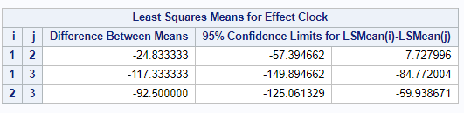  
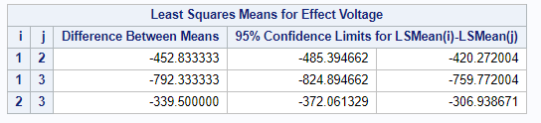



* + For the simple effects

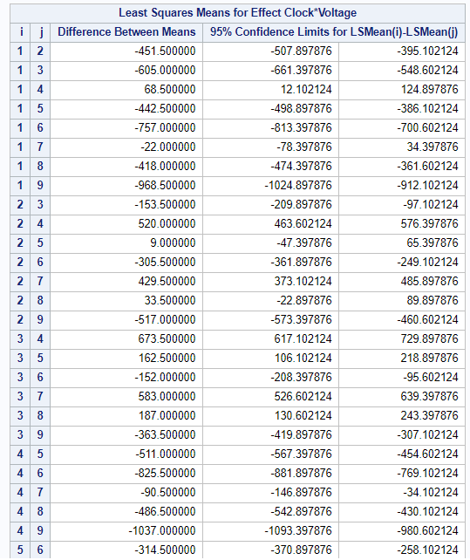

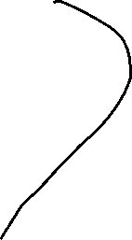

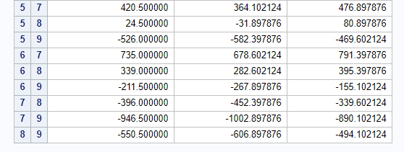­­



1. Interpretation of confidence intervals.
   * [2] Choose one of these confidence intervals for the **main effects** and interpret it within the context of the problem.

We are 95% confident that the mean CineBench R23 Score with a voltage set at -80.1 mV is between --420.27 and 485.39 points more than the mean CineBench R23 score with the voltage set at its default of 0 mV.

* + [2] Choose one of these confidence intervals for the simple effects and interpret it within the context of the problem.  
      
    Simple effect of Voltage (from 0mV to -160.2mV: 7 to 9) when CPU clock speed is 3.5 GHz is: (890.10, 1002.89). Focusing on when the CPU clock speed was 3.5 GHz, we are 95% confident that the average Cinebench R23 score when voltage is -160.2mV is between 890.10 and 1002.89 points more than when voltage is at 0 mV.

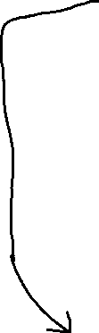

* [2] Choose one of these confidence intervals above and show how it is calculated from the formula.  
   Simple effect:   
  Estimate t* x SE t* = 2.2621571628



SE = SD x leverage factor 24.93(sqrt(1/2 +1/2)) = 24.93



946.5+/- 2.2621571628 (24.93) = (890.10, 1002.89)



1. [2] Write a paragraph summarizing your results. Overall, how did your two factors affect the response?  
     
   What I found during my experiment is that both factors (Voltage and clock) significantly affected the CPU performance as measured by the scores from the synthetic benchmark Cinebench R23. This occurred when voltage decreased and clock speed increased. However, it’s important to note that while both factors were significant in affecting the CPU performance, tuning the voltage down affected CPU performance more than changing the clock speed since it’s F-value is significantly larger at 1525.38 compared to the Clock speed’s F-value of 36.91. We can also see evidence of this in the interaction plot posted on problem 26 where clock speed stays relatively consistent (until the voltage hits -160.2 where clock speed starts to have a greater impact on Cinebench scores) while changes in voltage consistently illustrates the starkest difference between CPU performance scores.

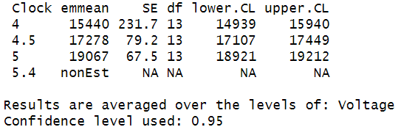

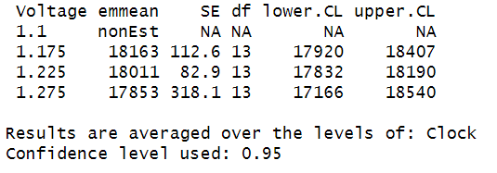

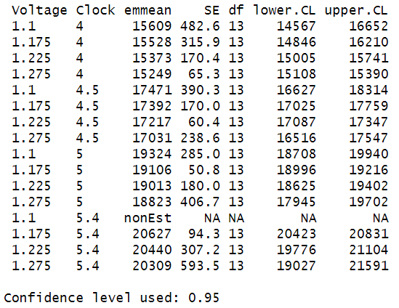

For the simple effects I need to make sure I got the right one graph above because I may need to have one that includes the interaction term

Conclusion / What you learned

1. [1] What did you expect the results of your experiment to be and is that what happened?  
     
   I expected that as voltage decreased and the clock speed increased that the Cinebench R23 scores for the CPU would increase. That is mostly what happened but voltage played a much bigger role in increasing the scores of the cinebench R23 scores while clock speed didn’t play much of a factor until the voltage hit -160.2 mV.
2. [1] What problems arose during data collection and what would you have done differently if you could do your experiment again?  
     
   After refining this project from project 1, I had pretty much solved the problems I encountered during data collection last time and no new problems arose during this experiment as everything went surprisingly smooth.
3. [1] Were there unexpected sources of variation, bias, and/or confounding you didn’t anticipate? What were they and what did you do about them?

Nope, not at all. Like I detailed in the previous question all the biases/confounding stuff I had found during project 1 was ironed out and refined so that they would not happen again during project 2 and no new problems arose during this experiment.

1. [1] What further questions/study are inspired by your experiment?  
   One study that I would like to do in the future that was inspired by this experiment is testing ‘real world performance increases’ of changing factors such as the CPU clock speed and voltage to see how it affects a video games performance. So, for project 1 and 2 I tested CPU performance on a synthetic benchmark (Cinebench R23), but in the future I would like to see how these changes directly relate to FPS (Frames per second – which makes the game look smoothers) increases in an actual game.